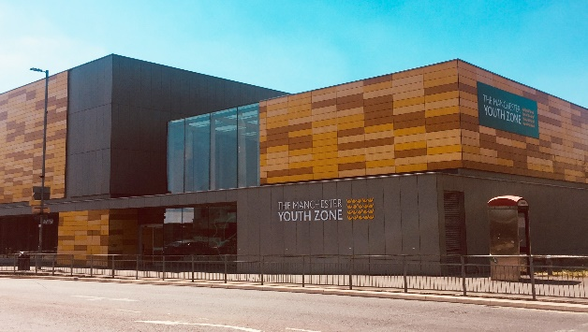
Corporate Fundraising Manager
Harpurhey, Manchester
Salary £30,000 - £32,500
40 hours per week – (to include some evenings and weekends)
Reports to: Director of Fundraising

Why work for Manchester Youth Zone
- Annual leave entitlement of 33 days (pro-rata)
- We are committed to training and developing our staff, that will include a full induction and access to internal and external training opportunities
- We care about your wellbeing – Access to our EAP, an extra holiday day for your birthday, and onsite gym and sports facilities
- 5% pension contribution
- You will be part of our mission to positively impact the lives of young people in North Manchester
The Manchester Youth Zone first opened to young people in 2012 as an independent charity. Located in Harpurhey enables the Manchester Youth Zone to reach the young in our community. We are a purpose driven, passionate team, with an ambition to give young people a pathway to a brighter future.
We work with young people aged 8-19 and up to 25 for those with additional needs offering provision during the day (including weekends) for targeted young people, each evening for universal provision and residential provision as part of specific programmes. The Manchester Youth Zone has an excellent reputation in a number of areas including safeguarding, working with young people who are “at risk” of criminal exploitation, mentoring and employment skills. We have invested strongly in partnership working, becoming a community asset responding to the needs of young people and the local community of North Manchester.
Please visit our website to learn more about the work we do!

Job Description
We’re recruiting a Corporate & Philanthropy Fundraiser that will be responsible for fundraising campaigns and initiatives in order to retain, recruit and grow income from corporate and individual supporters.
The successful candidate will have strong communication and networking skills, able to manage a portfolio of donors and prospects, identifying, cultivating, soliciting and stewarding as appropriate with an agreed annual income target.
You will work with our Communications and Marketing to engage senior leaders in business to support the work of Manchester Youth Zone through corporate volunteering campaigns, fundraising events, media campaigns and more.

Key Duties
- Be involved in the design and delivery of a tiered corporate and philanthropic giving programme to improve supporter engagement and income delivery
- To cultivate donor relationships that focus on donations of £250.00 to £20,000 with a view to developing multi-year agreements
- To develop and execute a tailored stewardship plan across all donors
- Work as part of a team to deliver a range of fundraising events and opportunities
- Track all fundraising activity on salesforce (training will be given) to evidence progression of relationships
- Encourage the participation of staff and young people and that their ideas contribute to fundraising campaigns, marketing and promotional activities
- Represent Manchester Youth Zone at external fundraising and networking events and forums
- To work effectively and positively alongside colleagues including staff, volunteers and young leaders. Ensure that all volunteers and trainee staff are made to feel an integral and valued part of Manchester Youth Zone family.
- Undertake regular training and development relevant to the role.
- Actively address any bullying, harassment, or discrimination, promoting cohesion, inclusion, and positive relationships.
- To understand and adhere to MYZ policies and procedures at all times with particular emphasis on equal opportunities, positive behaviour management, health and safety and safeguarding.
- Promote and safeguard the welfare of children and young people at all times, managing any safeguarding issues should they arise (training provided).
- To be an active member of the team and operate in line with the Charity’s expectations, values and principles. Work a flexible pattern including evenings and weekends in line with the role/team requirements.
- Carry out any other duties as may be reasonably determined by your line manager and be flexible to attend residential trips.
- Promote a positive image of MYZ through professionalism and good conduct with all our stakeholders and the public.
PERSON SPECIFICATION
 | Essential | Desirable | Identified by
Skills & Attributes
A successful track record in corporate/philanthropic fundraising and donor development | Y |  | CV
Experience in managing fundraising portfolios of a similar size |  | Y | CV  References
Ability to communicate effectively with a range of stakeholders, and promote the values and work of Manchester Youth Zone to wider audiences |  | Y | CV
Good numeracy skills with an ability to analyse and report on your own financial performance |  | Y
Experience
Planning and managing income generating campaigns – including monitoring budgets and expenditure | Y |  | Interview
Experience in cultivating and retaining donors | Y |  | Interview
Experience of using a CRM system for logging and tracking fundraising activity* |  | Y | CV  Interview
Knowledge, Understanding & Skills
Segmenting audiences and optimising fundraising messaging to raise awareness among different stakeholders |  | Y | CV  Interview
Fundraising best practice, legal requirements and financial processes* |  | Y | CV  Interview
Ability to communicate effectively with a range of stakeholders |  | Y | CV  Interview
Knowledge of the VCSE sector and the funding challenges |  | Y | CV  Interview
Additional attributes
Trustworthy and reliable | Y |  | CV  References
Organised and efficient | Y |  | CV  Interview
Excellent attention to detail and analytical | Y |  | CV
Passion for fundraising for a charity working with children and young people | Y |  | Interview
Commitment to personal & professional development | Y |  | Interview

