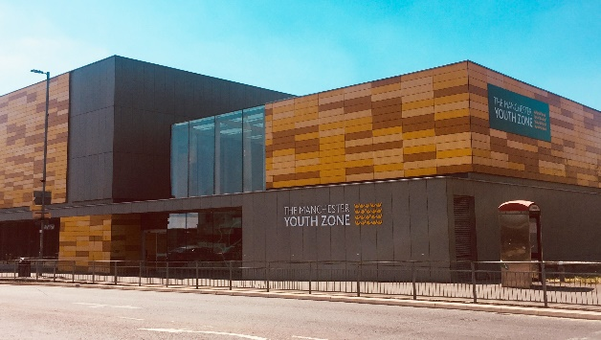
EMPLOYABILITY YOUTH WORKER
Harpurhey, Manchester
Salary £12 per hour
20 hours per week – (to include some evenings and weekends)
Reports to: Safe Space & Arts Manager

Why work for Manchester Youth Zone
- Annual leave entitlement of 33 days (pro-rata)
- We are committed to training and developing our staff, that includes access to internal and external training opportunities
- We care about your wellbeing – Access to our EAP, an extra holiday day for your birthday, and onsite gym and sports facilities
- 5% pension contribution
- You will be part of our mission to positively impact the lives of young people in North Manchester
The Manchester Youth Zone first opened to young people in 2012 as an independent charity. Located in Harpurhey enables the Manchester Youth Zone to reach those young people who need “Somewhere to go, something to do and someone to talk to”.
We work with young people aged 8-19 and up to 25 for those with additional needs offering provision during the day (including weekends) for targeted young people, each evening for universal provision and residential provision as part of specific programmes. The Manchester Youth Zone has an excellent reputation in a number of areas including safeguarding, working with young people who are “at risk” of criminal exploitation, mentoring and employment skills. We have invested strongly in partnership working, becoming a community asset responding to the needs of young people and the local community of North Manchester.
Please visit our website to learn more about the work we do!

Job Description
We’re looking for a Employability Youth Worker with excellent communication and relationship building skills. The successful applicant will lead on Manchester Youth Zone’s employability offer to NEET young people, ensuring all young people (from the age of 16 to 19, or 25 with additional needs) have access to our range of programmes.
The successful applicant will be responsible for supporting to deliver targeted programmes that include school presentations, centre-based 1-1 and small group support, work safaris (usually hosted by major donors) and other external employability events.

Key Duties
- To work directly with young people aged 16-19 (or 25 with additional needs) to deliver a high-quality employability offer which is structured around supporting young people and offering opportunities for levelling up
- Bringing new ideas and developing resources to ensure that young people can engage in diverse and engaging activities that support the development of soft skills
- Deliver high quality sessions and support the planning of a calendar of sessions that incorporate young people’s ideas, corporate partner offers, alternative education providers, external programmes, and meet the KPIs set by funded projects and organisation strategy
- Encourage the participation of young people and that their ideas contribute fully to the planning, delivery and evaluation of sessions
- To establish positive and engaging relationships with children from a range of backgrounds and provide interventions that will achieve outcomes such as development of soft skills, employability skills, confidence, and aspiration
- To establish strong relationships with a range of stakeholders that include corporate partners, external services, local schools and colleges, internal partners and more to recruit young people to programmes, deliver in line with project outcomes, job broker for young people and deliver a range of work experience opportunities to our members
- Support the mobilisation of projects and measure impact at each stage of the project. This will also include the development of reports (ensuring they meet project needs and are relevant to interested parties) and maintaining Salesforce with up-to-date information on young people who you have worked with (training provided)
- To be able to use your own initiative to flexibly meet the needs of children, adapting sessions where required to ensure inclusion
- To work with the wider team, to plan and deliver an offer which is inclusive, and meets the needs of all young people, including young people who do not engage in statutory services
- To work effectively and positively alongside colleagues including staff, volunteers and young leaders. Ensure that all volunteers and trainee staff are made to feel an integral and valued part of Manchester Youth Zone family.
- Undertake regular training and development relevant to the role.
- Actively address any bullying, harassment, or discrimination, promoting cohesion, inclusion, and positive relationships.
- To understand and adhere to MYZ policies and procedures at all times with particular emphasis on equal opportunities, positive behaviour management, health and safety and safeguarding.
- Promote and safeguard the welfare of children and young people at all times, managing any safeguarding issues should they arise (training provided).
- To be an active member of the team and operate in line with the Charity’s expectations, values and principles. Work a flexible pattern including evenings and weekends in line with the role/team requirements.
- Carry out any other duties as may be reasonably determined by your line manager and be flexible to attend residential trips.
- Promote a positive image of MYZ through professionalism and good conduct with all our stakeholders and the public.

PERSON SPECIFICATION
 | Essential | Desirable | Identified by
Skills & Attributes
Information & Guidance accreditation |  | Y** | CV
Proven track record in delivering similar sessions to young people aged 16-25 | Y |  | CV  References
Experience
Working with young people aged 16-25 years from a diverse range of backgrounds | Y |  | CV  Interview
Working with children who have experienced trauma or adversity through child focussed trauma responsive interventions* |  | Y | Interview
Delivering employability or enterprise-based sessions for NEET young people | Y |  | CV  Cover Letter
Networking and developing partnerships with a range of stakeholders |  | Y | CV  Interview
Working within a wider team to service users that benefit from targeted approaches | Y |  | Interview
Safeguarding children and young people* | Y |  | CV  Interview
Knowledge & Understanding
How to deliver IAG sessions to young people with an inclusive ethos |  | Y | CV  Interview
How to engage with young people effectively, and create young person-centred plans that support their development and career pathways |  | Y | CV  Interview
Knowledge of local organisations to signpost and build partnerships with |  | Y | CV  Interview
How to deliver practical employability sessions that include CV writing and interview preparation skills |  | Y
Ability to communicate effectively with a range of stakeholders by talking, listening, and writing factual and accurate recordings and reports* | Y |  | CV  Interview
Health and safety, equality, inclusion and diversity, safeguarding good practice and how these relate to children you work with | Y |  | CV  Interview
How to coach, encourage, motivate and raise the aspirations of young people | Y |  | CV  Interview
Effectively support and de-escalate children exhibiting challenging or anti-social behaviour* |  | Y | CV  Interview
Additional attributes
Organised and efficient, with an ability to multi-task and meet deadlines | Y |  | CV  Interview
Excellent attention to detail | Y |  | CV
Calm under pressure | Y |  | CV  Interview
Commitment to personal & professional development |  | Y | Interview
*training will be provided **potential opportunity to complete qualification in future

