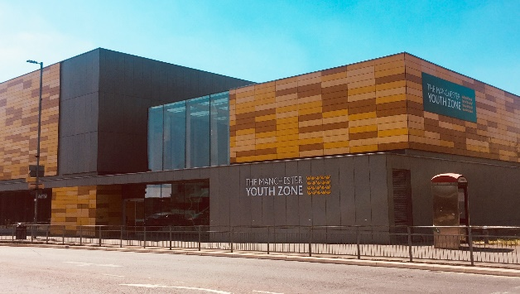
Business Development Administrator
Harpurhey, Manchester
Salary £28,000
40 hours per week – agile working applies
Reports to: CEO

Why work for Manchester Youth Zone
- Annual leave entitlement of 33 days (pro-rata)
- We are committed to training and developing our staff, that will include access to internal and external training opportunities
- We care about your wellbeing – Access to our EAP, an extra holiday day for your birthday, and onsite gym and sports facilities
- 5% pension contribution
- You will be part of our mission to positively impact the lives of young people in North Manchester
The Manchester Youth Zone first opened to young people in 2012 as an independent charity. Located in Harpurhey enables the Manchester Youth Zone to reach those young people who need “Somewhere to go, something to do and someone to talk to”.
We work with young people aged 8-19 and up to 25 for those with additional needs offering provision during the day (including weekends) for targeted young people, each evening for universal provision and residential provision as part of specific programmes. The Manchester Youth Zone has an excellent reputation in a number of areas including safeguarding, working with young people who are “at risk” of criminal exploitation, mentoring and employment skills. We have invested strongly in partnership working, becoming a community asset responding to the needs of young people and the local community of North Manchester.
Please visit our website to learn more about the work we do!

Job Description
We’re recruiting a Business Development Administrator that will be responsible for providing essential administrative support to the CEO and senior leadership team.
The successful candidate will be an effective communicator, well organised and be proficient in a range of IT systems including CRMs in order to produce information for use in a range of reports and other documents.
Taking minutes during board and committee meetings, organising diary meetings for the SLT and supporting with contract SLAs are just some of the key duties of this role.

Key Duties
- Provide personal administrative support to the CEO that includes diary management
- Share meeting agendas and take minutes for internal and external meetings, including trustee board and committee meetings
- Provide administrative support during internal investigation meetings that include meeting invites, minute taking, outcome reports etc
- Organise meetings across the organisation for specific workstreams or projects, as directed by the CEO
- Contribute to internal and external reports through collating, analysing and disseminating data as directed by the CEO
- Support the fundraising team with internal and external events – that includes the organising of media, resources and financial support where required
- Collaborate with the SLT to create efficient and effective systems and processes for; contract management, data management and general administration that are cost effective
- Create and distribute SLAs to delivery partners and tenants as directed by the SLT
- Support the finance & administration manager to create efficient processes for ordering resources
- Support the business operations team with procurement and management of suppliers
- Organise meetings with suppliers, delivery partners and other stakeholders as per SLA guidelines or as directed by the SLT
- Carry out any other reasonable PA, administrative or reception duties, as required

- Actively address any bullying, harassment, or discrimination, promoting cohesion, inclusion, and positive relationships.
- To understand and adhere to MYZ policies and procedures at all times with particular emphasis on equal opportunities, positive behaviour management, health and safety and safeguarding.
- Promote and safeguard the welfare of children and young people at all times, managing any safeguarding issues should they arise (training provided).
- To be an active member of the team and operate in line with the Charity’s expectations, values and principles. Work a flexible pattern including evenings and weekends in line with the role/team requirements.
- Carry out any other duties as may be reasonably determined by your line manager
- Promote a positive image of MYZ through professionalism and good conduct with all our stakeholders and the public.

Person Specification

Area | Method of assessment | Essential/  desirable
1.Experience
- Experience of diary management | C/I | Essential
- Experience of working in a busy office environment | C/I | Essential
- Experience of effectively communicating with a range of people, from different sectors and communities | C/I | Essential
- Experience of producing information for use in reports | C/I | Essential
- Experience of using databases to record information | C/I | Essential
2. Skills
- Ability to manage different work streams at once | C/I | Essential
- Ability to use a range of different processes and systems (electronic and paper) to ensure the business area runs smoothly and effectively | C/I | Essential
- Ability to communicate effectively, using different methods of communication, and develop relationships with a range of people and groups. | C/I | Essential
- Ability to manage own workload | C/I | Essential
- Ability to effectively use IT including Word packages, excel and databases | C/I | Essential
3.Knowledge
- Knowledge of the barriers that service users face when accessing mainstream services | C/I | Desirable
4.Education / training
a. High level of literacy demonstrating attention to detail and accuracy | C/I | Essential
b. High level of computer literacy (Word, database experience, outlook email & calendars, PowerPoint, Excel) | C/I | Essential
5. Personal
- Positive outlook and a ‘can do’ attitude | C/I | Essential
- Personal resilience and flexible attitude in the face of difficulties | C/I | Essential
- Commitment to working towards the MYZ missions and values including having a non-judgemental approach | C/I | Essential
- Commitment to personal development and willingness to regularly update skills and experience | C/I | Essential

