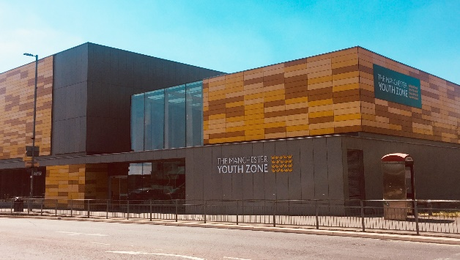
DETACHED – STREET BASED YOUTH WORKER
North Manchester
Salary £10.90 per hour
10-12 hours per week – afternoon/evenings
Reports to: Detached Co-Ordinator

Why work for Manchester Youth Zone
- Annual leave entitlement of 33 days (pro-rata)
- We are committed to training and developing our staff, that will include a full induction and access to internal and external training opportunities
- We care about your wellbeing – Access to our EAP, an extra holiday day for your birthday, and onsite gym and sports facilities
- 5% pension contribution
- You will be part of our mission to positively impact the lives of young people in North Manchester
The Manchester Youth Zone first opened to young people in 2012 as an independent charity. Located in Harpurhey enables the Manchester Youth Zone to reach those young people who need “Somewhere to go, something to do and someone to talk”.
We work with young people aged 8-19 and up to 25 for those with additional needs offering provision during the day (including weekends) for targeted young people and each evening for universal provision. The Manchester Youth Zone has an excellent reputation in a number of areas including safeguarding, working with young people who are “at risk” of criminal exploitation, mentoring and employment skills. We have invested strongly in partnership working, becoming a community asset responding to the needs of young people and the local community of North Manchester.
Please visit our website to learn more about the work we do!

Job Description
We’re looking for Youth Workers, with excellent youth work and communication skills to engage young people during detached and streets-based settings that include working on the Metro Link. We would like you to have experience in working in a detached setting and understand the differences between centre and detached based youth work. Communication and relationship building skills are key to this role and will rely heavily on working with third parties to identify key hotspots where young people congregate and may be at risk of harm or causing concern to the wider community in North Manchester.

Key Duties
- Deliver high quality detached sessions, which is safe, engaging, and developmental. This will include planning and delivery of regular detached sessions, and contribute towards the planning, delivery, and evaluation of specific projects.
- To work with co-ordinator to identify the hotspots where young people congregate and may be at risk of harm or causing concern to the wider community in North Manchester
- To build positive relationships with young people from a range of backgrounds who do not engage with services and provide interventions that achieve outcomes including helping them develop positive peer relationships, engagement in new activities, personal development, improved self-esteem, positive self-identity, acquisition of new skills, and developing wider networks of support
- To follow dynamic risks assessments that take account of the contextual safeguarding risks of delivering detached youth work in each location
- To support in critical incidents, liaising with centre-based staff and emergency and safeguarding services on the rare occasion required
- To support planning and programming, through negotiation and participation of young people in street-based settings, including identifying specialist staff and outreach venues for activities to take place
- Encourage the participation of young people and that their ideas contribute fully to the planning, delivery and evaluation of sessions, projects and activities.
- To provide opportunities for safe good quality one-one mentoring support for young people who identify as requiring additional support
- To be able to use your own initiative to flexibly meet the needs of young people, adapting detached sessions where required to ensure inclusion
- Effectively communicate at all levels both in terms of spoken conversations, planning and leading sessions, and developing short reports where required
- Maintain Salesforce with up-to-date information on young people who you have worked with (training provided)
- To work effectively and positively alongside colleagues including staff, volunteers and young leaders. Ensure that all volunteers and trainee staff are made to feel an integral and valued part of Manchester Youth Zone family.
- Undertake regular training and development relevant to the role.
- Actively address any bullying, harassment, or discrimination, promoting cohesion, inclusion, and positive relationships.
- To understand and adhere to MYZ policies and procedures at all times with particular emphasis on equal opportunities, positive behaviour management, health and safety and safeguarding.
- Promote and safeguard the welfare of children and young people at all times, managing any safeguarding issues should they arise (training provided).
- To be an active member of the team and operate in line with the Charity’s expectations, values and principles. Work a flexible pattern including evenings and weekends in line with the role/team requirements.
- Carry out any other duties as may be reasonably determined by your line manager.
- Promote a positive image of MYZ through professionalism and good conduct with all our stakeholders and the public.

PERSON SPECIFICATION
 | Essential | Desirable | Identified by
Skills & Attributes
A level 2 or above youth work qualification or equivalent |  | Y** | CV
Proven track record in delivering high quality street-based youth work | Y |  | CV  References
Experience
Working with young people aged 11-19years (up to 25) from a diverse range of backgrounds | Y |  | CV/Interview
Working with children and young people who have experienced trauma or adversity and may be resistant to engaging with professionals through child focussed trauma responsive interventions* |  | Y | Interview
Planning and working on detached youth work sessions | Y |  | CV/Cover Letter
Working effectively as part of a team | Y |  | CV/Cover Letter/Interview
Working with large groups of young people and managing group dynamics, including recognising when young people are not open to engagement | Y |  | Interview
Working with adults in the community who may be curious about the activity of detached youth workers and have an ability to build community trust and engagement |  | Y | Interview
Safeguarding young people with specific expertise on being able to identify and respond to harms outside of the family environment and activity that mitigates those risks |  | Y | CV/Interview
Knowledge & Understanding
National Occupational Standards for Youth Work (2020) and how these should be implemented in a variety of youth work settings* |  | Y | CV/Interview
How to engage with young people effectively and understanding the issues affecting their lives | Y |  | CV/Interview
How to plan, deliver and evaluate high quality programmes of activity with an inclusive ethos | Y |  | CV/Interview
Ability to communicate effectively with young people, parents/carers and colleagues by talking, listening and writing factual and accurate recordings and reports* | Y |  | CV/Interview
Health and safety, equality, inclusion and diversity, safeguarding good practice and how these relate to children you work with | Y |  | CV/Interview
How to coach, encourage, motivate and support children and young people to reach their full potential | Y |  | CV/Interview
Effectively support and de-escalate children and young people exhibiting challenging or anti-social behaviour | Y |  | CV/Interview
Additional attributes
Organised and efficient | Y |  | CV/Interview
Excellent attention to detail | Y |  | CV
Calm under pressure | Y |  | CV  Interview
Commitment to personal & professional development |  | Y | Interview
*Training will be provided **Potential opportunity to complete qualification in future

