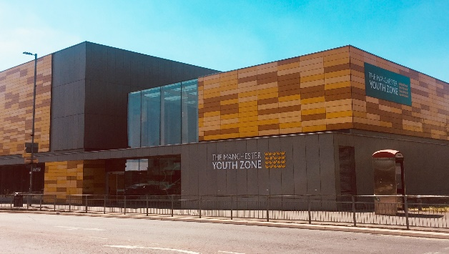
Programme Manager – Social Prescribing
Harpurhey, Manchester
Salary £32,000 - £34,000
40 hours per week – (to include some evenings and weekends)
Reports to: Head of Youth Services & Impact

Why work for Manchester Youth Zone
- Annual leave entitlement of 33 days (pro-rata)
- We are committed to training and developing our staff, that will include a full induction and access to internal and external training opportunities
- We care about your wellbeing – Access to our EAP, an extra holiday day for your birthday, and onsite gym and sports facilities
- 5% pension contribution
- You will be part of our mission to positively impact the lives of young people in North Manchester
The Manchester Youth Zone first opened to young people in 2012 as an independent charity. Located in Harpurhey enables the Manchester Youth Zone to reach those young people who need “Somewhere to go, something to do and someone to talk to”.
We work with young people aged 8-19 and up to 25 for those with additional needs offering provision during the day (including weekends) for targeted young people, each evening for universal provision and residential provision as part of specific programmes. The Manchester Youth Zone has an excellent reputation in a number of areas including safeguarding, working with young people who are “at risk” of criminal exploitation, mentoring and employment skills. We have invested strongly in partnership working, becoming a community asset responding to the needs of young people and the local community of North Manchester.
Please visit our website to learn more about the work we do!

Job Description
We’re recruiting a Programme Manager to launch a unique community based social prescribing hub which will provide preventive interventions to improve the nutritional, physical and mental health of young people and families in North Manchester.

This is a new and exciting Onside Foundation funded pilot programme which will provide holistic and targeted support to young people in the most deprived areas of Greater Manchester – the service will provide support to young people on all aspects of health and work with them to deliver targeted interventions and provide with them with the tools to make positive choices and meet their set goals.

You will be responsible for developing partnership working with various NHS and Local Authority stakeholders, developing mechanisms for social prescribing and feeding into the development programme. The successful applicant will line manage 5 navigators (responsible for families, emotional wellbeing, physical health and adolescent risky behaviours), and also be responsible for overseeing day to day safeguarding (alongside safeguarding officer and CEO).

Key Duties
- Be an effective line manager – 5 direct reports through regular supervisions and co-ordinating team meetings
- Develop and mobilise 3-year social prescribing model, initially launching a 1 year pilot, with years 2 and 3 being informed by the data gathered in year 1 (to include statistical data, case studies and youth voice)
- Working closely with the commissioning evaluation body to share data, impact and learning
- Monitor the safeguarding risk register and actions being taken by our safeguarding officer
- Take part in weekly case review meetings for safeguarding and families (internal), working to support your team with complex issues
- Regularly undertake internal audits of safeguarding practice within MYZ, ensuring results are shared with the team and support is put in place to resolve any concerns raised
- To ensure that all MYZ staff have a strong understanding of safeguarding and ability to act upon concerns and disclosures
- To establish positive, engaging and trusting relationships with young people from a range of backgrounds
- Build a portfolio of external agencies and programmes which the navigators and family support workers can access to support the needs of young people referred
- Work closely with the onsite delivery managers to build pathways for supported young people to access activities and sessions in an inclusive and supportive way
- Develop a sound knowledge of the activities and programmes being delivered both internally and within the local area to support the activity based responses and opportunities available to young people
- Effectively build relationships with external agencies to include Early help, M-Thrive, social workers, statutory agencies and other health providers to co-ordinate referrals, inform the agencies of support available, and demonstrate impact of the health impact project, as well as promoting other projects being delivered
- Develop a sound knowledge of local and Manchester based health providers and support the team to navigate these support services
- Effectively analyse data to create reports that will be shared with internal stakeholders (board members, delivery managers, HR and bid writers) and external stakeholders (commissioning body, Onside, health providers etc), ensuring that these reports are accurate, dynamic and demonstrate the impact of the project
- Confidently present information and impact to commissioners that is sensitive to the needs of young people, the project and can inform adaptation of KPIs where challenges arise
- Work closely with the independent designated safeguarding officer to inform of complex safeguarding cases, training needs of teams, local and emerging trends, and information they require for statutory meetings – guided by weekly case review meetings
- Maintain effective communication and sharing with the project steering groups
- Develop and maintain dashboards on Salesforce (training provided), ensuring that accurate and relevant data is captured
- Undertake regular training and development relevant to the role.
- Actively address any bullying, harassment, or discrimination, promoting cohesion, inclusion, and positive relationships.
- To work effectively and positively alongside colleagues including staff, volunteers and young leaders. Ensure that all volunteers and trainee staff are made to feel an integral and valued part of Manchester Youth Zone family.
- To understand and adhere to MYZ policies and procedures at all times with particular emphasis on equal opportunities, positive behaviour management, health and safety and safeguarding.
- Promote and safeguard the welfare of children and young people at all times, managing any safeguarding issues should they arise (training provided).
- To be an active member of the team and operate in line with the Charity’s expectations, values and principles. Work a flexible pattern including evenings and weekends in line with the role/team requirements.
- Carry out any other duties as may be reasonably determined by your line manager and be flexible to attend residential trips.
- Promote a positive image of MYZ through professionalism and good conduct with all our stakeholders and the public.

PERSON SPECIFICATION
 | Essential | Desirable | Identified by
Skills & Attributes
Youth work Level 3 or proven track record in managing within youth work settings | Y |  | CV  Interview
Proven track record in implementing projects and programmes | Y |  | CV
Proven track record of managing projects* |  | Y | CV  References
Experience
Working with a range of commissioning bodies (public and private sector) |  | Y | Interview
Mobilising complex youth work programmes | Y |  | Interview
Working with young people aged 8-25 years from a diverse range of backgrounds |  | Y | CV  Interview
Management or supervision of safeguarding (DSL training available) |  | Y | Interview
Line management* |  | Y | Interview
Knowledge & Understanding
National Occupational Standards for Youth work (2020) and how these should be implemented in a variety of settings* | Y |  | CV  Interview
How to plan and evaluate high quality programmes of activity with an inclusive ethos | Y |  | CV  Interview
Ability to communicate effectively with young people, colleagues and external stakeholders. Understanding the different communication styles required | Y |  | CV  Interview
Ability to demonstrate impact, using creative methods to report project outcomes to commissioning bodies |  | Y | CV  Interview
Additional attributes
Trustworthy and reliable | Y |  | CV  References
Organised and efficient | Y |  | CV  Interview
Excellent attention to detail and analytical | Y |  | CV
Solution focussed and ability to lead on multiple projects (up to 40) | Y |  | Interview
Commitment to personal & professional development | Y |  | Interview
Commitment to safeguarding young people and young people | Y |  | CV  Interview

