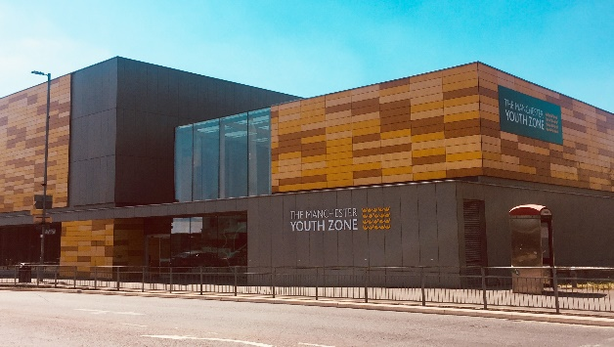
HOLIDAY CLUB YOUTH & PLAY WORKERS
Harpurhey, Manchester
Salary £10.90 per hour
16-20 hours per week
Reports to: Play Work Manager
Why work for Manchester Youth Zone
- We are committed to training and developing our staff, that will include a full induction and access to internal and external training opportunities
- We care about your wellbeing – Access to our EAP, an extra holiday day for your birthday, and onsite gym and sports facilities
- You will be part of our mission to positively impact the lives of young people in North Manchester
- 12.7% holiday pay
The Manchester Youth Zone first opened to young people in 2012 as an independent charity. Located in Harpurhey enables the Manchester Youth Zone to reach those young people who need “Somewhere to go, something to do and someone to talk”.
We work with young people aged 8-19 and up to 25 for those with additional needs offering provision during the day (including weekends) for targeted young people, each evening for universal provision and residential provision for specific programmes. The Manchester Youth Zone has an excellent reputation in a number of areas including safeguarding, working with young people who are “at risk” of criminal exploitation, mentoring and employment skills. We have invested strongly in partnership working, becoming a community asset responding to the needs of young people and the local community of North Manchester.
Please visit our website to learn more about the work we do!

Job Description
We’re looking for an individual who can deliver on a range of activities for our holiday club. This individual will have skills working with both children and young people, young people with additional needs/disabilities, targeted programmes to include detached, residential, community support and offsite trips.

Key Duties
- To work directly with children and young people in and out of the centre to facilitate safe, fun and developmental activities.
- To work in collaboration with both the youth and play teams, sharing your skill set across all areas of the Youth Zone.
- To develop your own collection of high-quality session and activity plans, so that you are able to deliver a suite of activities throughout the holiday club.
- To support on the planning and delivery of special events and trips
- Encourage the participation of children and young people and that their ideas contribute fully to the planning, delivery and evaluation of sessions, projects, and activities.
- To establish positive and engaging relationships with children and young people from a range of backgrounds and provide interventions that achieve outcomes including helping them develop friendships, try new things, personal development and growth into adolescence, improved self-esteem, positive self-identity, trying and learning new things through failure and success, and developing wider networks of family and agency support where required.
- To be able to use your own initiative to flexibly meet the needs of children and young people, adapting sessions where required to ensure inclusion
- Effectively communicate at all levels both in terms of spoken conversations, planning and leading sessions, and developing short reports where required. This also includes maintaining the attendance lists for activities. Ensure all recordings are well written for internal use and to be used to inform reports for external funders and interested parties.
- To work effectively and positively alongside colleagues including staff, volunteers and young leaders. Ensure that all volunteers and trainee staff are made to feel an integral and valued part of Manchester Youth Zone family.
- Undertake regular training and development relevant to the role.
- Actively address any bullying, harassment, or discrimination, promoting cohesion, inclusion, and positive relationships.
- To understand and adhere to MYZ policies and procedures at all times with particular emphasis on equal opportunities, positive behaviour management, health and safety and safeguarding.
- Promote and safeguard the welfare of children and young people at all times, managing any safeguarding issues should they arise (training provided).
- To be an active member of the team and operate in line with the Charity’s expectations, values and principles. Work a flexible pattern including evenings and weekends in line with the role/team requirements.
- Carry out any other duties as may be reasonably determined by your line manager and be flexible to attend residential trips.
- Promote a positive image of MYZ through professionalism and good conduct with all our stakeholders and the public.
PERSON SPECIFICATION
 | Essential | Desirable | Identified by
Skills & Attributes
Accreditation within youth work, play work or childcare |  | Y** | CV
Proven track record in delivering high quality sessions in similar settings | Y |  | CV
Flexibility to work in a variety of teams, at different times, and sometimes, at short notice | Y
Experience
Working with children and young people aged 8-25 years from a diverse range of backgrounds | Y |  | CV  Interview
Working with children who have experienced trauma or adversity through child focussed trauma responsive interventions* |  | Y | Interview
Planning and leading a range of sessions | Y |  | CV  Cover Letter
Working effectively as part of a team | Y |  | CV  Cover Letter  Interview
Working with large groups of children with high energy and managing group dynamics | Y |  | Interview
Safeguarding children and young people | Y |  | CV  Interview
Knowledge & Understanding
National Occupational Standards for Play work (2016) and youth work (2020) and how these should be implemented in a variety of settings* |  | Y | CV  Interview
How to engage with children effectively and understanding the issues affecting their lives | Y |  | CV  Interview
How to plan, deliver and evaluate high quality programmes of activity with an inclusive ethos | Y |  | CV  Interview
Ability to communicate effectively with children, parents/carers and colleagues by talking, listening and writing factual and accurate recordings and reports* | Y |  | CV  Interview
Health and safety, equality, inclusion and diversity, safeguarding good practice and how these relate to children you work with | Y |  | CV  Interview
How to coach, encourage, motivate and support children to reach their full potential | Y |  | CV  Interview
Effectively support and de-escalate children exhibiting challenging or anti-social behaviour |  | Y | CV  Interview
Additional attributes
Organised and efficient | Y |  | CV  Interview
Excellent attention to detail | Y |  | CV
Calm under pressure | Y |  | CV  Interview
Commitment to personal & professional development |  | Y | Interview

*Training will be provided **Potential opportunity to complete qualification in future

